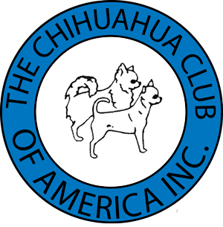
CHIHUAHUA CLUB OF AMERICA

VENDOR CONTRACT

CCA National Shows - October 11-15, 2023
Hyatt Place Dallas/Garland/Richardson
5101 N President George Bush Hwy
Garland, TX 75040

Set-Up Available 3:00-6:00p.m. Tuesday, Oct 10, 2023
ALL VENDORS MUST TAKE BOOTH SPACE FOR ENTIRE WEEKEND
LIMITED SPACE-BOOK EARLY. BOOTH SPACE IS INDOORS - AROUND THE RING
Booth Space: $150 per 10 foot space. Tables are not included but are available from hotel for $20 for the weekend.

Deadline For Reservations: September 30, 2023, after which time no refunds will be given for cancellations.

Vendors will be responsible for collecting their own sales tax. The Chihuahua Club of America shall assume no liability for accidents or loss and vendors must carry their own insurance.
The Chihuahua Club of America reserves the right to refuse space to any vendor. No booths will be accepted where human foods will be sold. The hotel has exclusive food sales rights No live animals may be sold or displayed. No alcoholic beverages allowed in the show room. Purina has exclusive dog food sales rights.

When making reservations please include the following:
Business Name Name
Address City ST___Zip ___
Cell Number: __________________Email ___ Size of Space needed:

YOUR CLEARED CHECK IS YOUR RESERVATION
Send checks payable to Chihuahua Club of America to:
Tracy Potts, Vendor Chair,
16619 Fort Oswego Street, San Antonio, TX 78247/ Tracypotts1@aol.com 210-365-3248
I agree to all conditions stated within. Vending & Selling of any items or products without Vendor Space will not be permitted. $25 fee will apply for returned checks.

VENDOR SIGNATURE DATE

