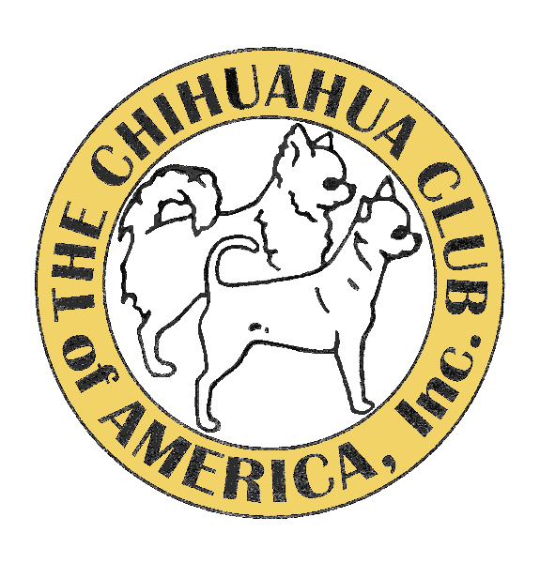CCA NATIONAL RV PARKING FORM

Parking forms must be snail mailed to: Lo Wolfson P.O. Box 99, Chiefland, Fl. 32644
The envelope must be POSTMARKED ON OR AFTER Monday, August 14th, 2023.

You will be notified by email when reservation is accepted, and check is received.
Form must be totally completed.

NAME-----------------------------CELL YOU CARRY------------------------EMAIL-----------------------
ADDRESS------------------------------------------------CITY---------------------------STATE----------ZIP---------
MH CLASS AND MAKE----------------------------------------------------LENGTH--------------------------
DATE ARRIVING {not before Tue, Oct 11th, 8am}---------------------------------------------------
MH PARKING RULES
All MH and Trailers must be fully self-contained. No dumping of gray water on the hotel grounds. Upon arrival after Tuesday, 8am, October 11th, look for Lo or call 352-256-2490 so I can park you. If you wish to be parked with someone, please arrive together.
Please include your check or money order for $150.00 made payable to CCA. Make sure your name is on the check. All rigs must be gone by Sunday evening. Please feel free to text or email Lo for any concerns or info you may need.
Be prepared to enter the hotel property with FULL WATER and EMPTY TANKS. Water is available behind the hotel, if needed. Generators must be vented above the roof with exhaust venting stacks.
I UNDERSTAND THE PARKING RULES AND WILL ABIDE BY ALL CCA DIRECTIVES:

----------------------------------------------------------------------
Signature required
Text or email and questions to: Lo Wolfson, PO Box 99, Chiefland, Fl 32644
352-256-2490
askforlo@bellsouth.net

